ACSL
American Computer Science League
2013 - 2014

Contest #1

Intermediate Division

1. Recursive Functions
Find (12) given:

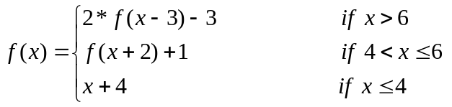
Where [n] represents the greatest integer ≤ n
- Recursive Functions
Find (10,2) given:
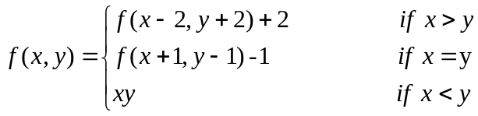

3. Computer Number Systems
Find the average of the following. Express the answer in octal.

110111₂ 63₁₀ 3A₁₆ 124₈

4. Computer Number Systems
Which of the following has the most 1’s in its binary representation?

178₁₆ 567₈ 101110110₂ 565₈ 377₁₀

- What Does This Program Do?
What is printed when this program is run?
a = 10 : b=5 : c=20 : d=1 : e=2
if a + b > c / e then b = a - b else c = c * e
if a / b = c / b then a = b + 2 * e else d = b ^ 2
if (a > b) and (c > d) then e = d / b else b = a + c / e
if (a + c > d * e) or (b / c = b / (2 * a)) then b = a - e
else c = b - c
if (a < b) or (c < d) and (b + e = a) then d = d - c else c = c / a
print c / (b + e) – d ^ 2 + a / e
end

